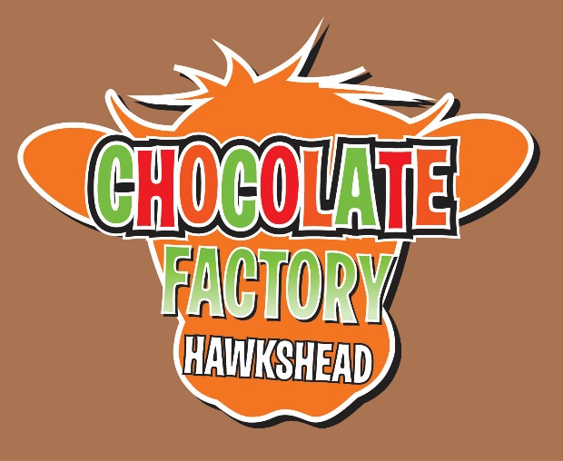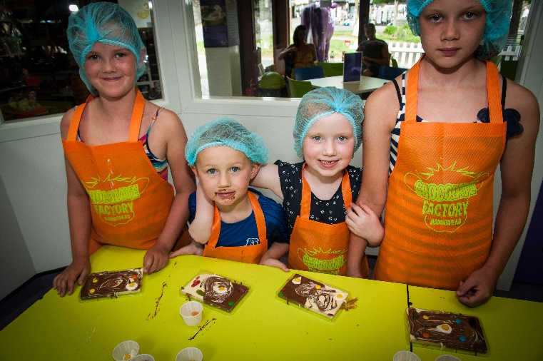
Main Street, Hawkshead, Cumbria, LA22 0NT
CHILDRENS BIRTHDAY PARTIES
£18.50
Includes full workshop experience plus a decorated party table with kids lunch box (includes sandwich, packet of crisps, biscuit & carton of juice) plus birthday present for the birthday girl or boy.
- Minimum requirement 8 children
- Please advise us in advance of any special dietary requirements.
- We request a £50 deposit to secure the booking
- Allow approximately 1.5 hours for the workshop and party food
- We are happy for you to bring your own birthday cake and add any additions to the food already included
- Please let us have your sandwich requirements 2 days before the party
- Unless we have 24 hours notice of any reduction in the number of children, you will be charged for the number originally booked.

Please contact us on 015394 36075 or email
andrew@chococolatefactoryhawkshead.co.uk
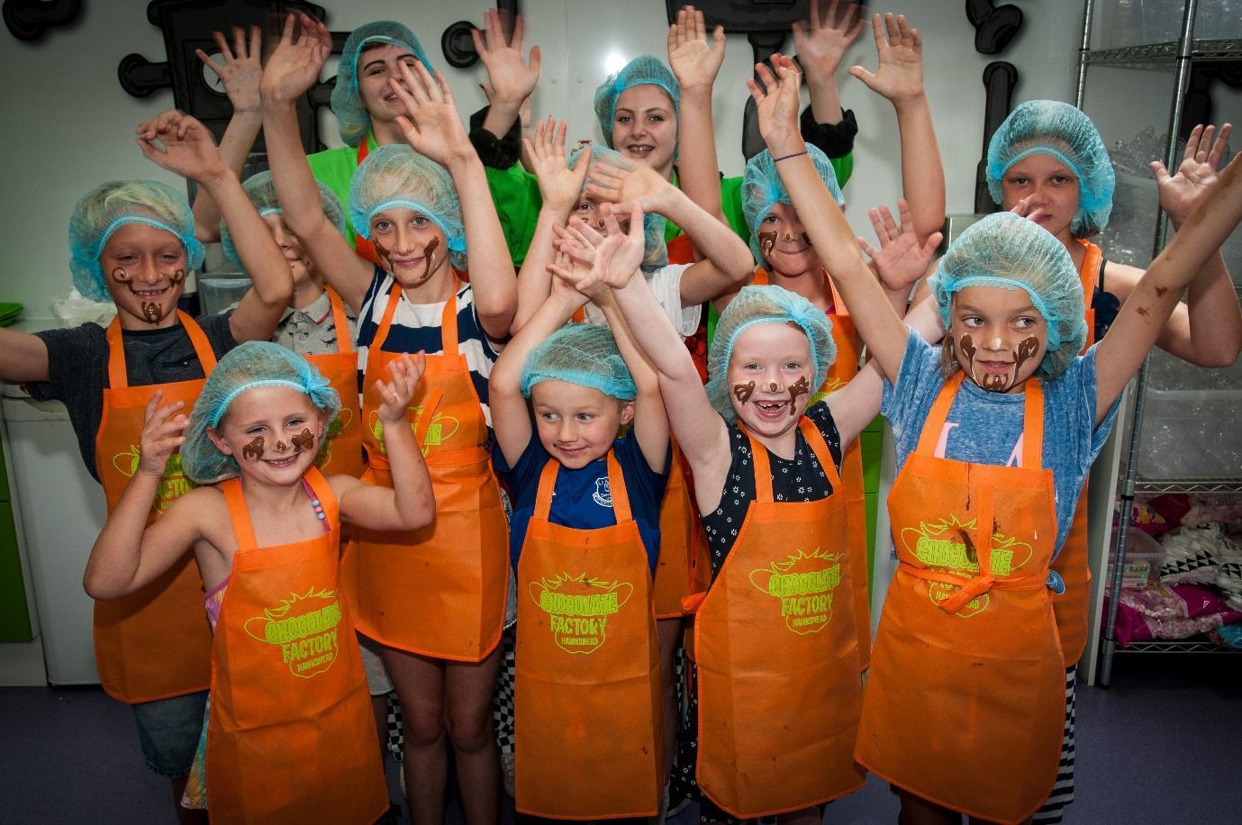

Kids Lunch Box options
CHILDS NAME | SANDWICH | CHEESE | HAM | JAM | BUTTER

